NAME: MUHAMMAD RAFLY ABDILLAH

NRP: 5025231085

1. QUERY

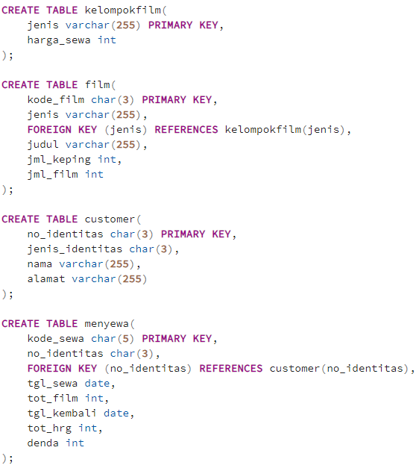

RESULT

1. QUERY

RESULT

1. QUERY

1. QUERY



RESULT

1. QUERY

RESULT

1. QUERY

RESULT

1. QUERY

RESULT

1. QUERY

RESULT

1. QUERY

RESULT

1. QUERY

RESULT

